The 7th UNESCO UNITWIN International Conference on Quality Teacher Education 2023
Presenters’ Profile
BUNYAMIN MAFTUH
Photo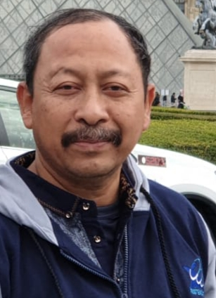 | Professor, Faculty of Social Science Education, Universitas Pendidikan Indonesia, Bandung, Indonesia  1986 – Now : Teaching staf. Universitas Pendidikan Indonesia, Bandung, Indonesia  2009 – 2011 : Program Officer, SEAMEO Secretariat, Bangkok, Thailand.  2015 – 2019 : Director for Career & Competency Development, Ministry of Research, Technology & Higher Education, Indonesia  2020 – 2023 : Vice Rector for Research, Business & Partnership, Universitas Pendidikan Indonesia  Research Interest: Social Studies & Citizenship Education  Email: bunyaminmaftuh@upi.edu

