The 7th UNESCO UNITWIN International Conference on Quality Teacher Education 2023
Presenters’ Profile

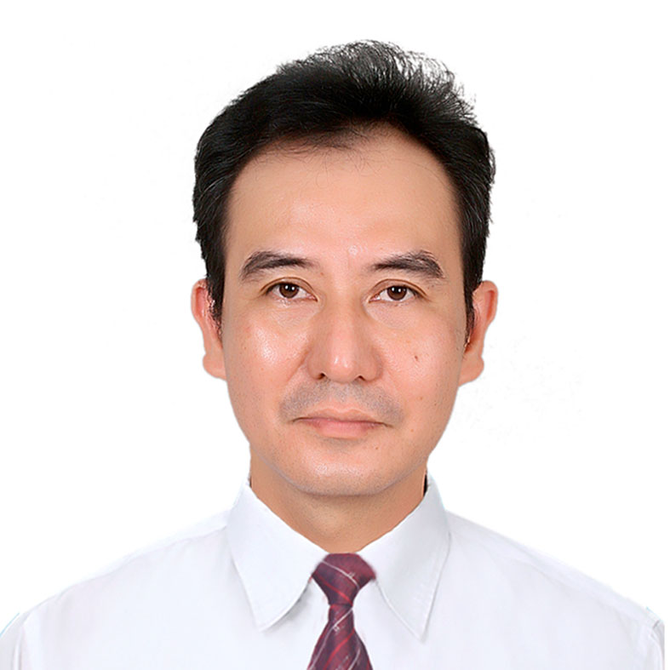 | Assoc.Prof. Pham Kim Chung,  Faculty of Educational Technology,  University of Education, VNU, Vietnam  ₋ Vice dean of Faculty, Faculty of Educational Technology,  - Ph. D. in Didactic of Physics, Hanoi Education University (2011)  Research Interests: Didactic of Physics, ICT in Physics Education, Teacher professional development, STEM education  Email : chungpk@vnu.edu.vn

