The 7th UNESCO UNITWIN International Conference on Quality Teacher Education 2023
Presenters’ Profile

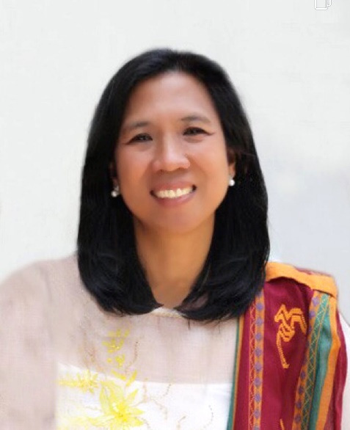 | ELENITA N. QUE, Ph.D.  Associate Professor, Faculty of Education, University of the Philippines  Dr. Elenita N. Que is an Associate Professor and Program Coordinator of the Educational Technology Area at the University of the Philippines College of Education. She has a Master’s Degree in Educational Technology from the University of the Philippines and a Ph.D. in Education focusing on Comparative Education and ICT Education at Hiroshima University in Hiroshima, Japan. She is a Digital Literacy Fellow at Queensland University of Technology in Brisbane Australia. She is a course developer, learning experience designer, researcher, and teacher trainer.  Research Interests: instructional design, instructional technology, curriculum studies, reflective teaching, comparative education, education in difficult contexts  Email : enque@up.edu.ph

