The 7th UNESCO UNITWIN International Conference on Quality Teacher Education 2023

Presenters’ Profile
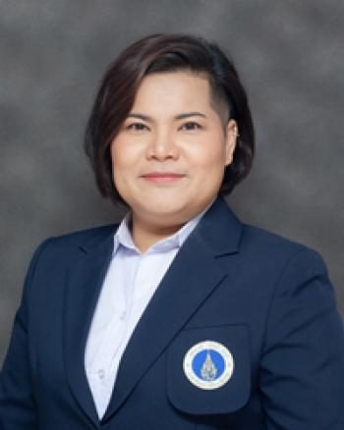  Nitima Sutapin, Ph.D. | Lecturer, Science and Liberal Arts Division, School of Interdisciplinary, Mahidol University Kanchanaburi Campus (MUKA), Thailand  Lecturer, Science and Liberal Arts Division, School of Interdisciplinary, Mahidol University Kanchanaburi Campus (MUKA) (Apr 2015 - Present)  Faculty Senate, Mahidol University Kanchanaburi Campus (MUKA) (June 2020 - Present)  Mahidol University Kanchanaburi Campus Committee on Mahidol University Professional Standard Framework (MUPSF) (October 2022 - Present)  Mahidol University Kanchanaburi Campus Digital KM Committee (October 2022 - Present)  Student Development Committee, Mahidol University Kanchanaburi Campus (MUKA) (May 2017 - Present)  Student Cooperative Education and Internship Committee, Mahidol University Kanchanaburi Campus (MUKA) (August 2018 - Present)  Lecturer, English Language Division, Liberal Arts Faculty, Mahidol University (June 2014 - Mar 2015)  Lecturer, English Language Division, Education Faculty, Chandrakasem Rajabhat University (June 2012 - October 2013)  Ph.D., Curriculum and Instructions, Silpakorn University, Thailand (2019)  Research Interests: English Language Teaching, Critical Reading and Thinking Instructions, Task-based Approach, Business English Instruction, Language Testing and Assessment, STEAM Education, and Curriculum and Instructions  Email: nitima.sut@mahidol.ac.th

