The 7th UNESCO UNITWIN International Conference on Quality Teacher Education 2023
Eun Young Jung
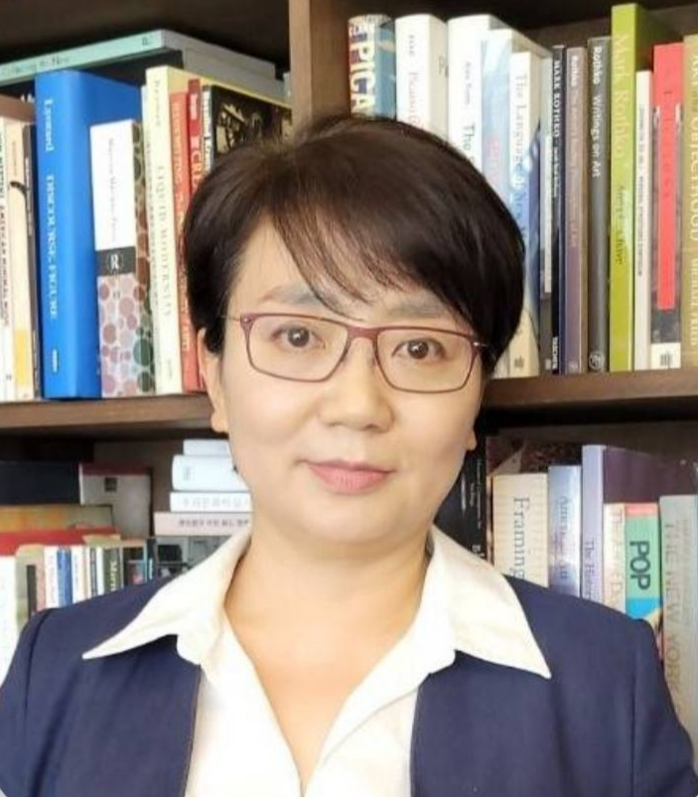 | Professor, Department of Art Education, Korea National University of Education, Korea  Education and Academic Career  2001 – 2006 : PhD in Art History, University of Illinois at Urbana-  Champaign, USA  2018 – 2019 : Department Chair, Department of Art Education, KNUE  Head, Graduate Program of Art Education, KNUE  2018 – 2020 : President, The Korea Assoication for History of Modern Art;  Academic Division Chair, Korea Art Education Association  2021 – 2022 : Editor in Chief, The Korea Association for History of Modern Art  2023 – present : President, The Korean Society of Art History  Director, Center for Education of Arts, KNUE  Publications: “The Return of Wastes: Heterological Strategies of Contemporary Art and Its Expansion” (KCI Journal, KAHOMA, 2023); “My Form: Moon Shin’s ‘Plastic Arts’ and Linear Form” (KCI Jounal, KBAH, 2022); “A Reflective Analysis on New Media Art Education Using Augmented Reality : Focused on Socially Engaged Art Lesson in High School” (Corresponding Author, KCI Journal, The The Korean Society of Science and Art, 2022), etc  Research Interests: Mondern and Contemporary Art and Theories; Critical Discourses of Arts, Science, Technology; STEAM and Convergence Education; Artificial Intelligence in Art and Culture  Email : eyjung313@knue.ac.kr

